Math 1309 Quiz 3 – Spring 2012 Name:

This quiz is due on Monday, February 6 during class. No late assignments will be accepted.

- Use the limit definition of derivative to find f’(x) for 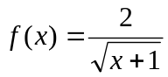

- Find the indicated derivatives
a) 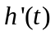 if 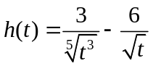 b) 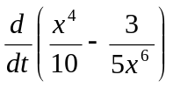

c) 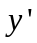 if 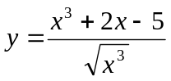 d)  if 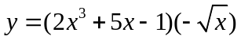

3. Let 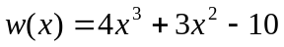

- Find 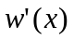

b) Find the value(s) of x where the tangent line to the curve is horizontal (recall that a horizontal line has slope zero)

5. The table below contains data from the production of coffeecakes at a bakery. p is the price (in dollars) of one coffeecake for a daily demand of x coffeecakes , and C is the total cost in dollars of producing x coffeecakes

x | p | C
125 | 9 | 740
170 | 7 | 785

a) Use the data in the table to find the price-demand equation assuming that the relationship between p and x is linear
b) Find the revenue function. Determine the domain using the price-demand equation found in (a) (round to the nearest coffeecake)
c) Use the data in the table to find the total cost function assuming that the relationship between C and x is linear. What are the variable and fixed costs?
d) Find the profit function and the marginal profit function
e) Find the marginal profit at production levels of 100 and 300 items and interpret your result.
f) What production levels will result in a gain (positive profit)?

5. A marine manufacturer estimates that the company will sell N(x) boats when they spend x thousand dollars in advertising, where N(x) is given by
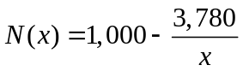
a) Find 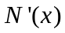

- Determine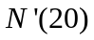. Interpret your result being as specific as you can about quantities and units and indicating if the boat sales are increasing or decreasing.

